Blinkit Data Project
Project Brief
- Blinkit deals as quick commerce company that runs the business across India, distributed in different states.
- With the increase in the number of daily orders in India. The company is planning to shift its traditional data management and analysis to a better tool.

Problem Statement:
As the business scales, the existing traditional methods of managing and analyzing inventory data have become inefficient, leading to challenges in stock tracking, damaged goods reporting, and supply chain decisions.
The company requires a modern, interactive, and real-time data visualization solution to:
- Track inventory stock levels across different locations.
- Analyze trends in stock received and damaged stock.
- Monitor product-level performance and stock movement over time.
- Enable decision-makers to act quickly based on data-driven insights.

Goal of the Project
The goal of this project is to build an interactive Power BI dashboard that helps the operations and supply chain teams to better understand inventory dynamics and make informed business decisions.

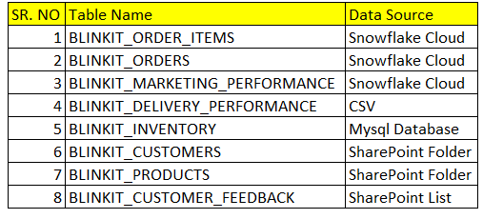
Data Sources:

- Note that the stakeholders wish to see the marketing performance data in real time.

This is the current phase document, the next phase document will be released soon.

